CS 340 README Template

About the Project/Project Title

This project is a Python CRUD module developed for Grazioso Salvare. The module provides a reusable interface between a Python application and a MongoDB database that contains records from the Austin Animal Center. The module connects to the MongoDB database aac and the animal’s collection using the PyMongo library. It now has Create, Read, Update, and Delete functionality letting users create new animal records into the database and query existing records while also being able to update existing records and delete existing records.
Building on the CRUD module developed in Project One, Project Two adds an interactive dashboard using the Dash framework. The dashboard lets users to view animal records in an interactive data table, filter records based on categories, see the breed distributions with a pie chart, and display animal locations on a map. The purpose of the application is to help Grazioso Salvare find dogs that meet the requirements for Water, Mountain, and Disaster rescue programs.

Motivation

The purpose of the project is to create a reusable Python module that simplifies interactions between the Python application and the MongoDB database. It is important to have a way to perform database operations without constantly writing database connection and query code. The CRUD module was made to separate database functionality from the user interface making the code easier to maintain and expand.
Project Two builds on this by adding a dashboard that allows users to access animal shelter data through a web interface. The dashboard provides filtering options, a data table, breed distribution pie chart, and a geolocation map to show where the animals are located.
Grazioso Salvare needs this application to help them identify which dogs are good candidates for search and rescue based off certain parameters (breed, age, and gender).

Getting Started

To recreate Project One, you need to setup a MongoDB database environment. Then import the Austin Animal Center (aac) outcomes dataset into MongoDB using the database name “aac” and the collection name “animals”. After you import the data create a user account with read and write permissions to the aac database.
Then you will create a Python module file named CRUD_Python_Module.py. Using the PyMongo library establish a connection to the MongoDB server. Then you will implement the Create operation using the insert_one() method, the Read operation using the find() method, the Update operation using the update_many() method, and the Delete operation using the delete_many() method.
After completing the CRUD module, create a Jupyter notebook testing script that imports the module, instantiates the AnimalShelter class, insert a record into the database, retrieves that record using the Read function, updates that record using the Update function, and removes the record using the Delete function.
To recreate Project Two, you need to create a dashboard application using the Dash framework. Connect the dashboard to the MongoDB database through the CRUD module and get all records from the animal’s collection. Then you will add a data table, filtering options, a pie chard showing different breeds, and a map showing where the animals are.
The dashboard should have filtering options for Water, Mountain, and Disaster rescue as well as Reset. Then you will add the Grazioso Salvare logo and a unique identifier. Then test all functionality of the dashboard to make sure it is working as expected.

Installation

Python: was used as the primary language for developing the CRUD module. It has strong support for database integration.
MongoDB: was used as the database system for storing the Austin Animal Center (AAC) animal records.
Codio: was the cloud-based development environment for the project.
PyMongo: Was used to establish connections to MongoDB and perform the Create and Read operations within the Python module.
Jupyter Lab: Was used to create and run the testing notebook.
Dash: Was used to build the dashboard interface and manage callback functionality
Plotly Express: Was used to generate the interactive pie chart
Dash Leaflet: Was used to create the interactive geolocation map.

Usage

Code Example

The example below shows how to import the CRUD Python module, instantiate the AnimalShelter class, create a new animal record, retrieve that record, update the record, and delete the record.

#TODO: import for your CRUD module
from CRUD_Python_Module import AnimalShelter
#TODO: Instantiate an instance of your class
shelter = AnimalShelter()
#TODO: Use your create function create a new record in the aac database
new_animal = {
"animal_id": "A12345",
"name": "Abraar Test Dog",
"breed": "Golden Retriever"
}
result = shelter.create(new_animal)
print ("Create Result:", result)
#TODO: Use your read funtion to return records from the aac database
results = shelter.read({"animal_id": "A12345"})
print("Read Result:", results)
#TODO: Test update function
updated = shelter.update(
{"animal_id": "A12345"},
{"name": "New Updated Abraar Test Dog"}
)
print ("Update Result:", updated)
updated_record = shelter.read({"animal_id": "A12345"})
print("Updated Record:", updated_record)
#TODO Test delete function
deleted = shelter.delete({"animal_id": "A12345"})
print("Delete Result:", deleted)
after_delete = shelter.read({"animal_id": "A12345"})
print("After Delete:", after_delete)

This example shows the completed Create, Read, Update, and Delete functionality implemented in the CRUD Python module.
In Project Two the CRUD Python Module is used as the data access layer for the dashboard application. The dashboard gets records from MongoDB through the CRUD module and displays them on the data table.

Tests
The CRUD Python module was tested using a Jupyter notebook file. The testing process confirmed that all the CRUD functions were working as expected. The Create function was tested by inserting a sample animal record into the aac.animals collection. The function returned True confirmed that the document was inserted. The Read function was tested by querying the database using the unique animal_id and successfully returning the matching document. The Update function was tested by changing the name field of the sample record and verifying the change using the Read function. The Delete function was tested by removing the sample record and confirming the deletion by performing another Read query that returned an empty list. These tests showed all CRUD operations working as expected.
The Project Two dashboard was tested by connecting the application to the MongoDB database and checking if all dashboard components were working correctly, The data table was tested by loading all the records from the AAC database and making sure the pagination and sorting was working correctly. The rescue category filters were tested to make sure the correct queries were being executed. The pie chart was then tested to make sure the breed distributions changed based off the rescue category selected. Finally the geolocation map was tested by selecting specific records from the database and confirming the map showed the correct location.

Screenshots

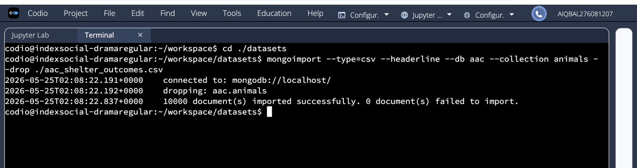

Screenshot 1:

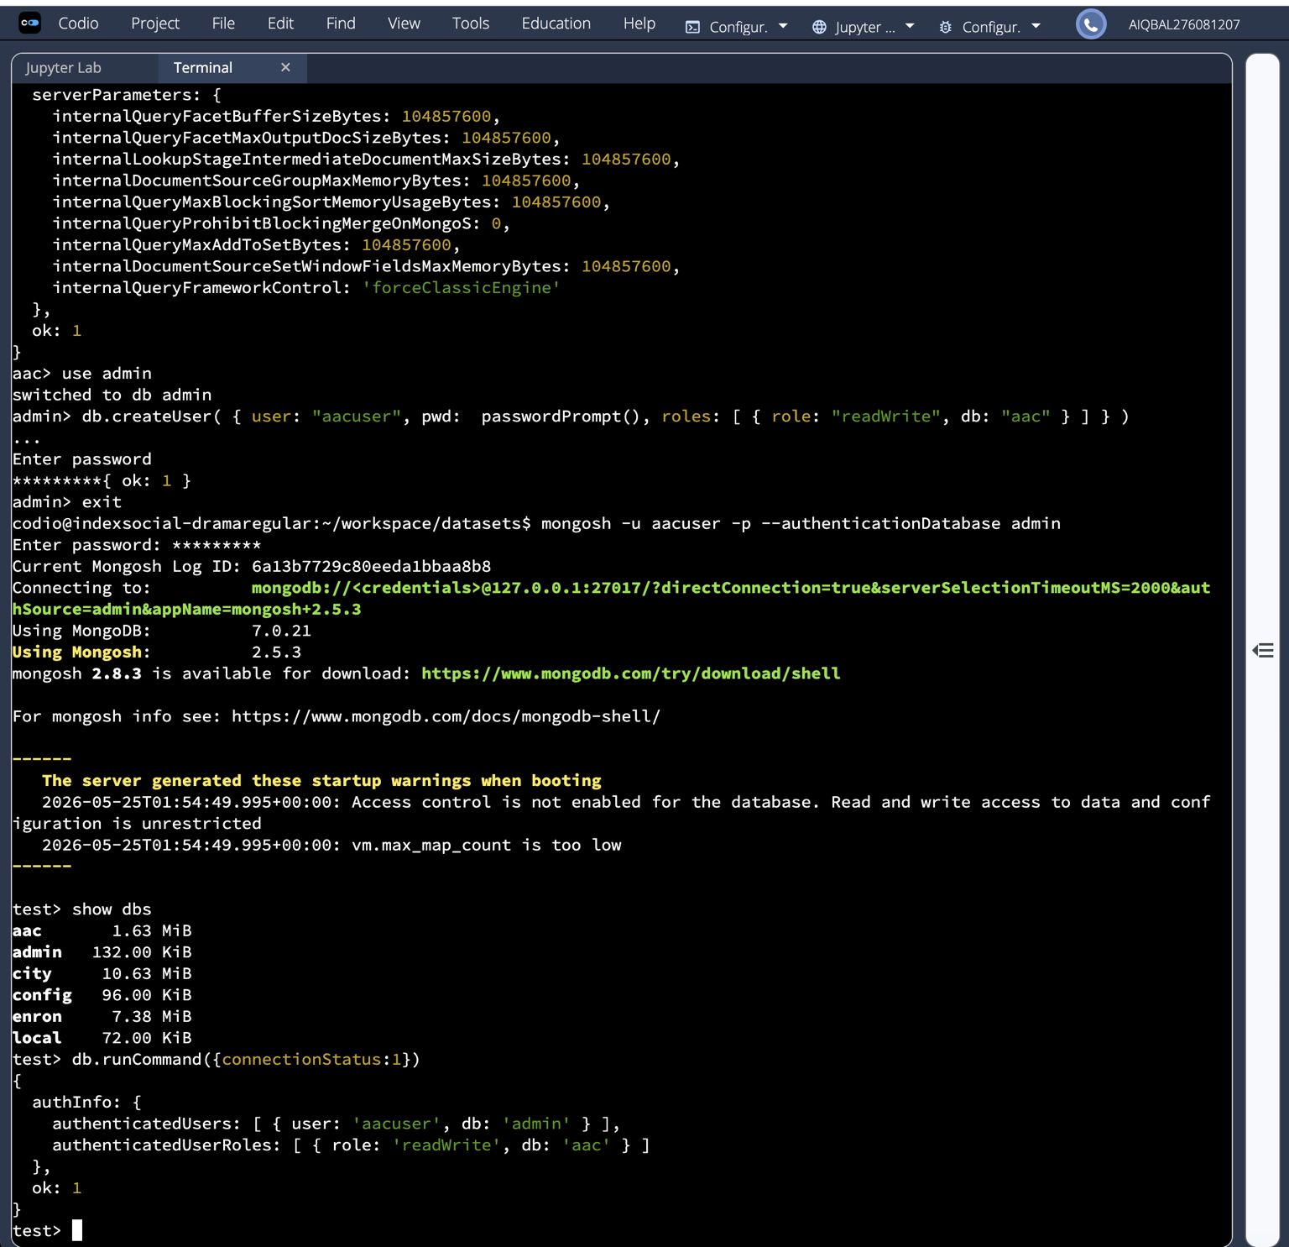
Screenshot 2:

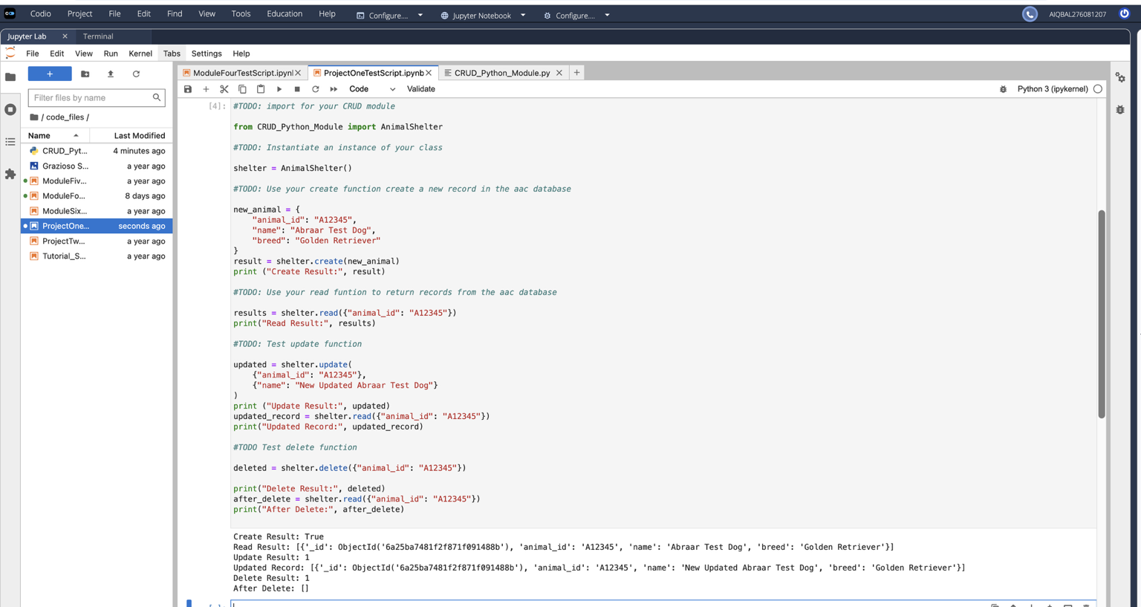

Screenshot 3:

Required Functionality:
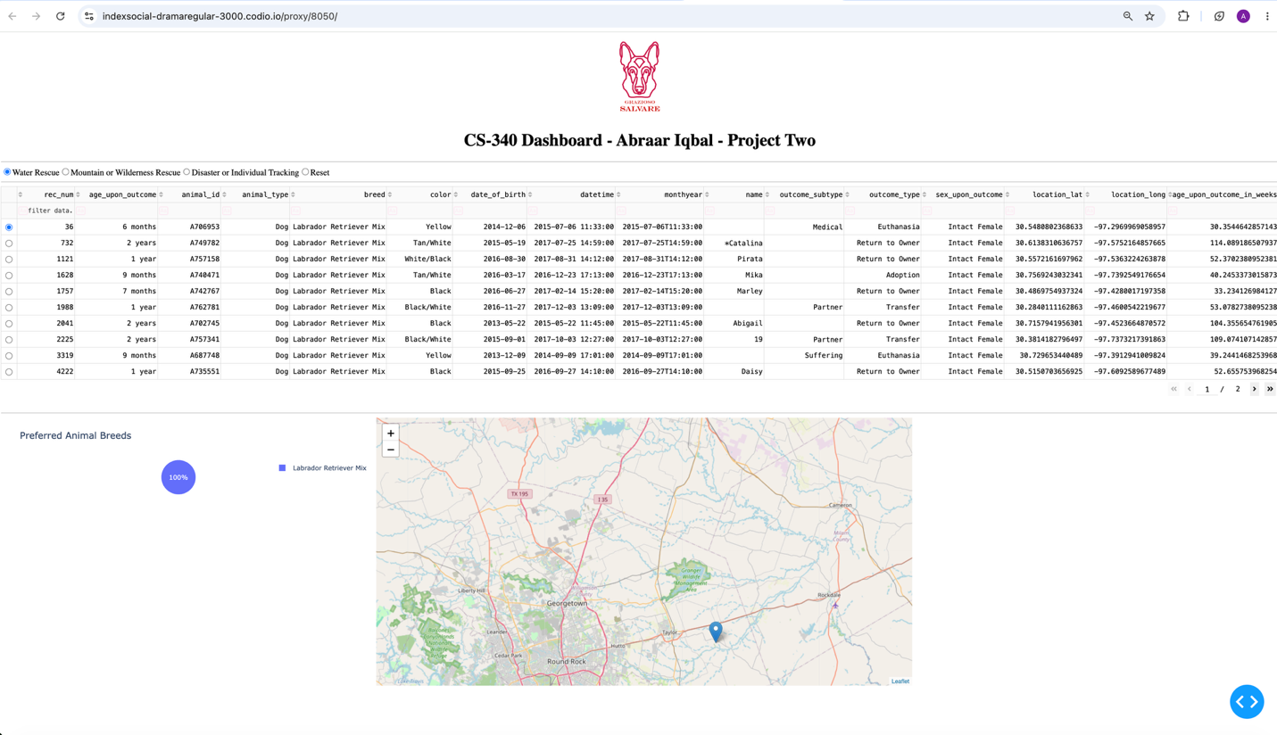
- Screenshot 1: (Water Rescue)

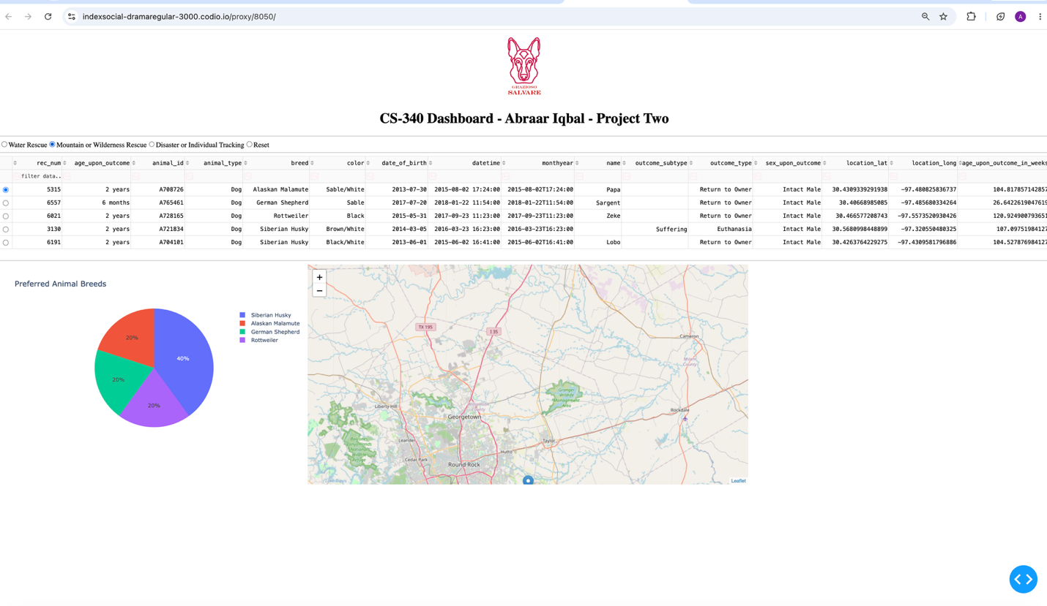

Screenshot 2: (Mountain or Wilderness Rescue)

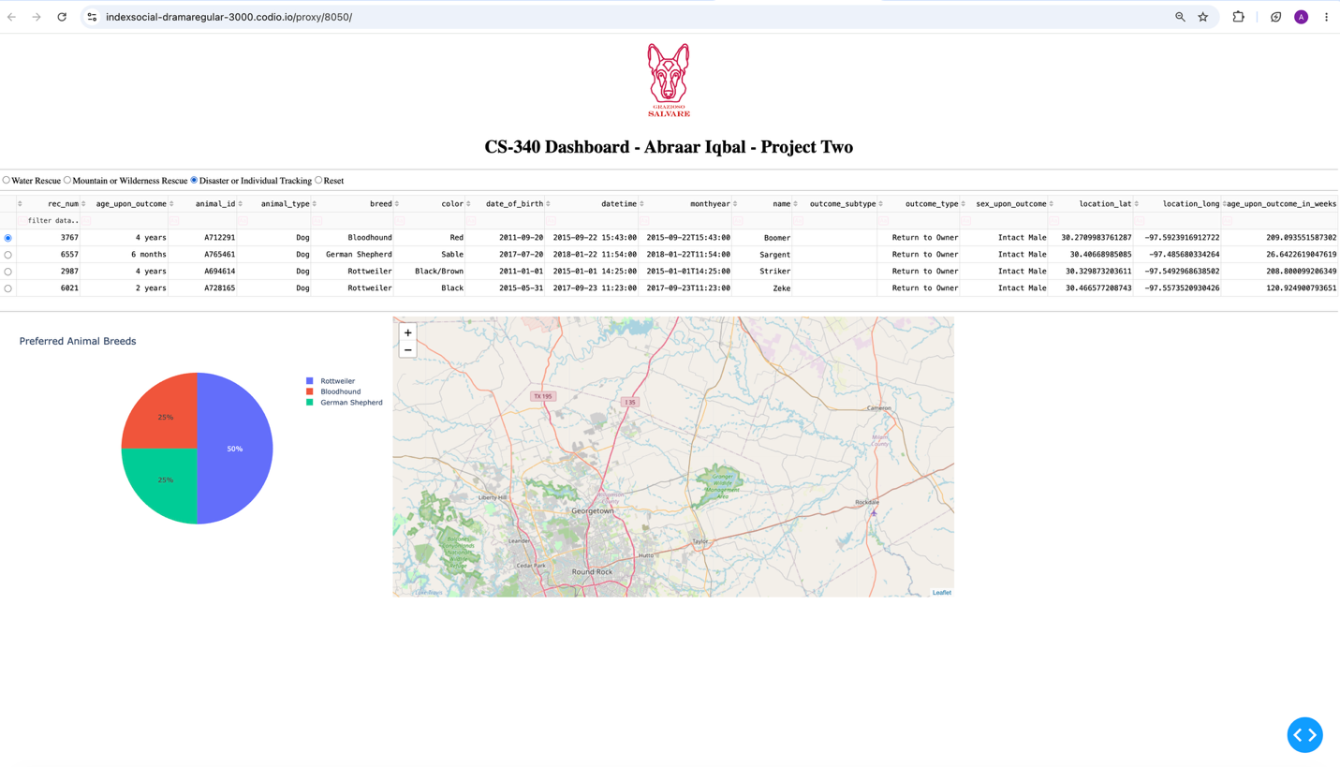

Screenshot 3: (Disaster or Individual Tracking)

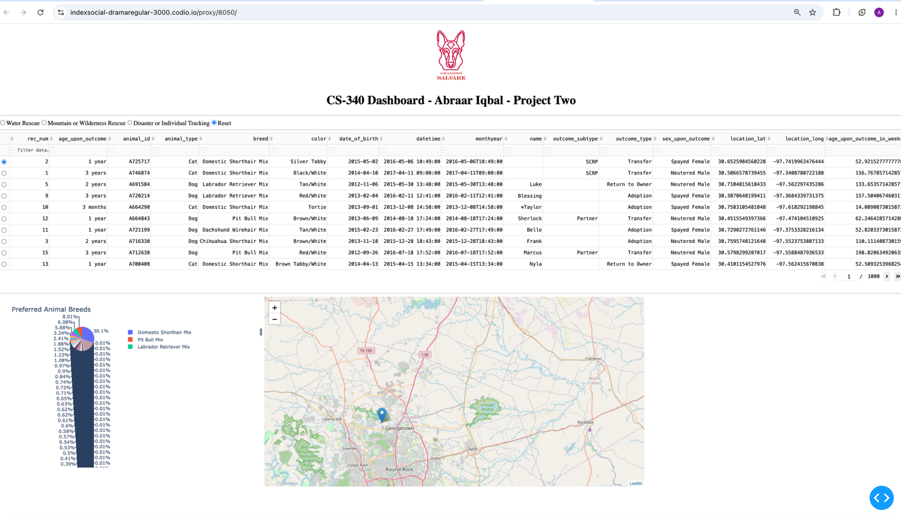

Screenshot 4: (Reset returns all widgets to their original, unfiltered state)

Challenges:

One challenge I had was working with the MongoDB cursor returned by the find() method. I fixed this by converting the cursor to a list before returning the results. The Update method was implemented by using the update_many() function and returning the number of modified records. The Delete method was implemented by using the delete_many() function and returning the number of deleted documents.
Another challenge was creating MongoDB queries that correctly matched the rescue dog requirements. The rescue categories needed filtering by age, breed, animal type, and gender. I kept testing and editing the queries until the correct records were returned for each category.

Resources Used:

Codio.com
Mongodb.com

Contact
Abraar Iqbal
abraar.iqbal@snhu.edu

